Computer architecture research paper

CE 242

David Finger

Colorado Technical University

Table of Contents

Table of Contents

Business Organizational Background 4

Spice of Life. 4

Business model 4

Modern Computer Organizations and Design 5

Front end devices 5

Back end devices 5

Digital Logic Design 6

Analog 6

Digital 6

Computer Memory and Data Representation 7

Bit 7

Bit string 7

Character 7

Decimal 7

Integer 7

Floating points 7

ASCII characters 7

Memory 8

Cache 8

Main memory 8

Secondary memory 8

Storage 8

Storage mediums 8

SSD’s 8

Assembly Language Programming 9

Compilation process 9

Pre-Processing: 9

Compiling: 9

Assembly: 9

Linking: 9

Input / Output Organization 11

Summary and Final Recommendation 12

Resources 13

Computer Architecture Research Paper

# Business Organizational Background

## Spice of Life.

Spice of life is an active coffee shop operating in the middle of the city that posts local artists work as decoration. Spice of life also posts prints available both instore and online for purchase.

### Business model

Currently operating in one location inside Seattle, Washington.

Spice of life has 6 employees: 1 manager, 1 assistant manager, 2 baristas, 1 sales associate, and 1 talent acquisition.

Has local WIFI, 2 registers with iPad ordering for POS, iPad for sales of artist works, desktop for postings and online orders.

# Modern Computer Organizations and Design

## Front end devices

2 cash drawer registers connected to iPad with PoS software and card readers for sales.

Mobile iPad with POS software for artist sales.

## Back end devices

WIFI router

Desktop computer running x64 operating system for timecards, inventory, and memos.

# Digital Logic Design

## Analog

Analog computers are very basic in their use as they operate on mathematical variables in the form of physical quantities that are constantly changing. Analog computers main functions are to take data and allow the user to create a mathematical model for use in computation. These devices are handy for showing solutions in graphical manners in little time. Analog computers are things like slide rulers, sextants, and tide predictors, all objects that are used to calculate things that are constantly changing.

## Digital

Digital computers deal with mathematical variables in the form of numbers that represent specific values of physical items. Digital machines work on numbers, specifically they take variables and convert them into binary, or 1 and 0, and use the sequences of 1 and 0 to do all calculations. These include modern computers, laptops, and digital calculators. These devices are versatile, reprogrammable, accurate, and less affected by outside disturbances.

# Computer Memory and Data Representation

## Bit

Bits are 0 and 1 from the binary number system. This system uses positional notation to express its data.

## Bit string

Bit strings are sequences of bits that are used to represent sets or manipulate binary data.

## Character

Characters are encoded in computer memory within character sets so that all letters and numbers can be read properly.

## Decimal

Decimal number systems are comprised of the numbers 0,1,2,3,4,5,6,7,8, and 9. Called digits this system uses positional notation to express its data.

## Integer

Integers can be either signed or unsigned but both represent a range of 256 distinct numbers. Signed integers range from 0 to 255 while unsigned integers range from -128 to 127.

## Floating points

Floating point numbers are expressed in scientific notation with a fraction, exponent, and radix, through the equation Fxr^e. floating point numbers suffer from loss of precision when represented in fixed bit lengths.

## ASCII characters

ASCII represents characters in 128 characters with values 0 to 127. This means that 7 bits are used to represent a character with a reverse byte being used to identify the characters to the computer system.

## Memory

### Cache

Designed to allow the data that is used most often to be instantly available.

### Main memory

Main memory is used for the temporary storage of data. Includes ROM, RAM, EEPROM, and DRAM.

### Secondary memory

Secondary memory refers to external storage devices that allow for permanent storage.

## Storage

### Storage mediums

Hard drives are used in computers as permanent storage of data. These drives are widely available but take a good amount of time, as far as computer speeds go, to read or write data to them.

### SSD’s

Solid State Drives are a upgrade from current hard drives for storage because instead of writing data to a physical disc all information is stored in microchips that allow for faster access.

# Assembly Language Programming

## Compilation process

The compilation process contains 4 steps. Those steps are Pre-processing, compilation, assembly, and linking.

### Pre-Processing:

Pre-Processing is the first stage of compiling and it is where all user written comments are removed, all macros are expanded into full code, and all files get expanded to be their full codes as well.

### Compiling:

Compiling takes the output of Pre-processing, which is a file with the name filename.i and parses it into a new file named filename.s. this file is in assembly code and provides all instructions to the assembly language to show how it will need to correctly link and align everything for the final output.

### Assembly:

Assembly is where the assigned assembly language takes filename.s and assembles those instructions into machine code so that it can be fed into the linker to ensure that everything within the file runs correctly

### Linking:

Linking is the final stage of a compiler, as such it adds the most extra code to the program. This code ensures that all links within the file, such as include(studio.h), are included and can be executed when the file is run. This is also where a lot of the bulk from code comes from as linking adds all links and all debug steps to running code.

# Input / Output Organization

## Interrupt initiated I/O

To prevent computer CPU’s from being constantly used, interfaces have input special commands that allow the CPU to stop working on something to work on something else using an interrupt code.

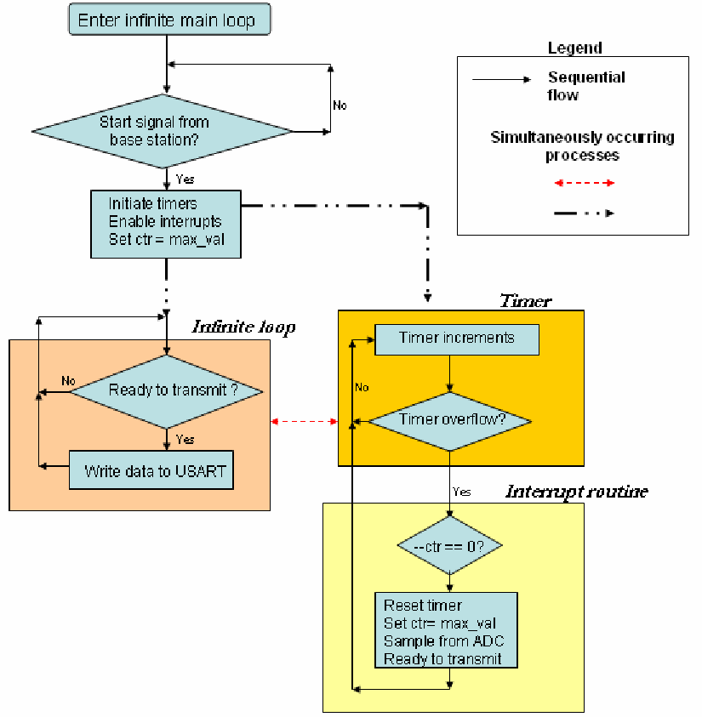

# Summary and Final Recommendation

Using current computers and ipads for ease of use it would be very easy to run spice of life almost indefinitely. Using back office x64 desktop computer for shipments and time clocks, while using the arm on the ipads for orders and PoS, spice of life would be able to run easily.

# Resources

How to Differentiate between Analog and Digital Computers. (n.d.). Retrieved August 29, 2018, from <https://www.brighthubengineering.com/diy-electronics-devices/97571-difference-between-analog-and-digital-computing/>

A Tutorial on Data Representation - Integers, Floating-point numbers, and characters. (n.d.). Retrieved September 6, 2018, from <http://www.ntu.edu.sg/home/ehchua/programming/java/datarepresentation.html>

Compiling a C program:- Behind the Scenes. (2015, November 12). Retrieved September 12, 2018, from <https://www.geeksforgeeks.org/compiling-a-c-program-behind-the-scenes/>

Figure 34. Flowchart demonstrating how timer/interrupts were generated... (n.d.). Retrieved September 19, 2018, from <https://www.researchgate.net/figure/Flowchart-demonstrating-how-timer-interrupts-were-generated-to-control-sampling-rate_fig31_254967659>